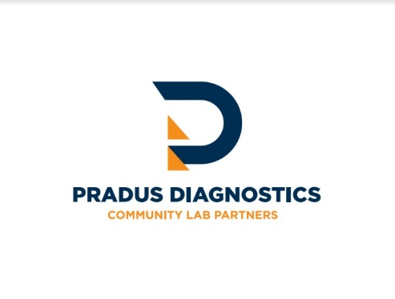
Dear Healthcare Provider,
We want to remind you of your responsibility as a qualified healthcare provider to ensure that laboratory tests are ordered only when medically necessary for treating your patients. When ordering diagnostic panels, it is important to include diagnosis codes that support the necessity of the test requisitions.
As a provider of molecular testing panels, including our Respiratory Pathogen Panel with COVID-19, we understand that ordering test panels can sometimes result in tests that are not medically necessary. Therefore, providers must ensure that each component of an ordered panel is medically necessary for each patient. If the full test panel is not medically necessary, we recommend ordering a more targeted test to ensure your patients receive appropriate care.
Regarding our Respiratory Pathogen Panel (RPP), it is important to note that it is intended for the multiplex diagnosis of symptomatic patients to determine the causative agent or coinfections. It is not intended as a single-COVID test or for work or travel-screening purposes.
We would also like to bring to your attention the CMS Laboratory Documentation Policies. Laboratory tests must be ordered by the provider treating the beneficiary and using the results to manage the beneficiary’s specific medical problem. The provider who ordered the test must maintain documentation of medical necessity in the beneficiary’s medical record. Furthermore, lab requisitions must include an original or electronic provider signature, as Medicare does not allow stamped or copied signatures.
Supporting documentation includes clinical evaluations, physician evaluations, consultations, progress notes, physician’s office records, hospital records, nursing home records, home health agency records, records from other healthcare professionals, and test reports. Acceptable communication methods for test orders include a written document, a telephone call, or an electronic mail.
For any questions or concerns regarding Pradus Diagnostic Solutions compliance practices, please use the online anonymous compliance form on our website or contact our Chief Compliance Officer directly.
We also provide additional resources, such as information on CMS National and Local Policy Coverage Determinations and the current Medicare Fee Schedule.
By reading and understanding the information in this Annual Compliance Notice, you acknowledge your responsibilities as an authorized referrer for clinical laboratory testing. We appreciate your commitment to providing the best possible care for your patients.
Sincerely,
Pradus Diagnostic Solutions

